ONEWAY Memory BY Temp
/STATISTICS DESCRIPTIVES HOMOGENEITY WELCH
/PLOT MEANS
/MISSING ANALYSIS.

Oneway

Notes
Output Created |  | 05-May-2019 23:52:12
Comments
Input | Active Dataset | DataSet0
Input | Filter | <none>
Input | Weight | <none>
Input | Split File | <none>
Input | N of Rows in Working Data File | 30
Missing Value Handling | Definition of Missing | User-defined missing values are treated as missing.
Missing Value Handling | Cases Used | Statistics for each analysis are based on cases with no missing data for any variable in the analysis.
Syntax |  | ONEWAY Memory BY Temp  /STATISTICS DESCRIPTIVES HOMOGENEITY WELCH  /PLOT MEANS  /MISSING ANALYSIS.
Resources | Processor Time | 00 00:00:00.187
Resources | Elapsed Time | 00 00:00:00.195

[DataSet0]

Descriptives
Memory
 | N | Mean | Std. Deviation | Std. Error
Between 22°C-18°C | 9 | 86.5433 | 22.40580 | 7.46860
Between 24°C-26°C | 6 | 77.1667 | 32.12229 | 13.11387
In between 24°C and 22°C | 13 | 109.3615 | 38.38285 | 10.64549
Less than 18°C | 2 | 84.2500 | 23.68808 | 16.75000
Total | 30 | 94.4030 | 33.66618 | 6.14658

Descriptives
Memory
 | 95% Confidence Interval for Mean |  | Minimum | Maximum
 | Lower Bound | Upper Bound | Minimum | Maximum
Between 22°C-18°C | 69.3207 | 103.7660 | 60.75 | 138.00
Between 24°C-26°C | 43.4564 | 110.8769 | 48.00 | 140.00
In between 24°C and 22°C | 86.1670 | 132.5561 | 55.50 | 166.00
Less than 18°C | -128.5789 | 297.0789 | 67.50 | 101.00
Total | 81.8318 | 106.9742 | 48.00 | 166.00

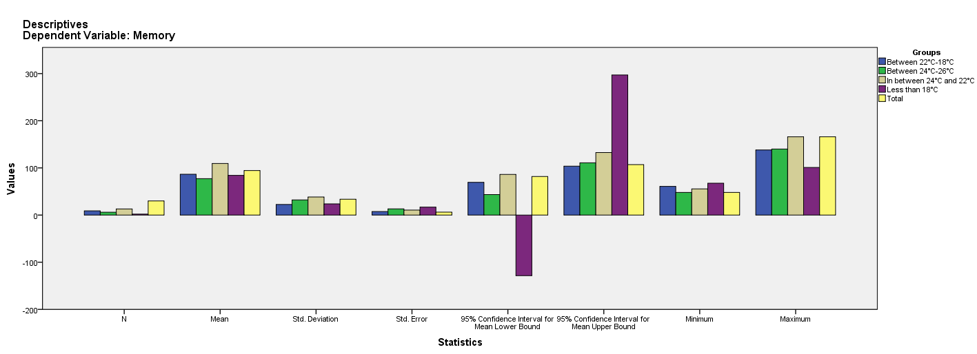

Test of Homogeneity of Variances
Memory
Levene Statistic | df1 | df2 | Sig.
2.031 | 3 | 26 | .134

ANOVA
Memory
 | Sum of Squares | df | Mean Square | F | Sig.
Between Groups | 5453.536 | 3 | 1817.845 | 1.724 | .187
Within Groups | 27415.409 | 26 | 1054.439
Total | 32868.945 | 29

Robust Tests of Equality of Means
Memory
 | Statisticª | df1 | df2 | Sig.
Welch | 1.200 | 3 | 4.842 | .402
a. Asymptotically F distributed.

Means Plots

